Robert Alexander Schumann
Ali Meihls
Music 1010
Salt Lake Community College

The artist I decided to write about is Robert Schumann who was born on June 8th 1810 in Zwickau Germany. At the young age of 7 Robert started playing piano and during that year he wrote short piano dances, which were the beginning to his career as a classical composer. In this paper I want to talk about a few things, first being his personal history, then his music and finally how he has impacted the musical world with his works.
Robert’s father August was one of the only people in his life that supported his musical aspirations. When he dies in 1826 Robert was left with his mother who wanted him to do something different with his life. Robert then went to school at the University of Leipzig to study law. A short year later he decided that it wasn’t the right path for him so he quit school and went back to composing songs. Schumann’s piano teacher was Friedrich Wieck, together they worked hard to get Schumann to be no less than perfect at the piano, but in that process Robert’s right hand was destroyed, his dreams of being a pianist were over at this time, but he still had his dreams of composing.
While pursuing his dreams of composing he fell in love with his former piano teachers daughter, Clara Wieck who was 8 years younger than Schumann but was already a famous pianist. Within the year Robert asked Clara’s dad, Friedrich for her hand in marriage, unfortunately he was told he did not have permission. That didn’t stop Robert and Clara; they ignored her father’s wishes and went on to get married that same year. Sources claim that the year following their marriage was the best for Schumann as a composer. During this year he wrote over 150 songs, most of which were love songs inspired by his new wife.
During 1844 after traveling around Russia with Clara they returned to Dresden where Robert became ill. This was more of a mental illness due to the fact that he would shiver and fear death anytime he heard metal instruments, including keys or was in high places. He constantly had the sound of an A note stuck in his head which also caused suffering for someone who had such a passion for music. This illness eventually went away in 1846 and Robert was able to return to his career as a composer. This wouldn’t last for long however, in 1854 just 8 years after his illness went away it started back up. Instead of just hearing the A note this time, he heard voices telling him what to do. He was a theme told by two former composers while in his sleep and he turned around and made 5 different versions of this piano piece, which would be his last work as a composer. At the young age of 44 Robert Schumann’s career had ended due to his mental illness. For someone like Robert who had loved music practically his whole life, giving it up did not come easy. In February of 1854 he tried to commit suicide but was rescued by some boatmen who made sure to get him help. As it turns out, Robert had been suffering from syphilis, from this diagnosis he was treated in an asylum and remained there until his death on June 29th 1856 at the age of 46.
The next part of Robert Schumann’s life that I want to talk about are his compositions. He completed 4 symphonies, 5 overtures, around 8 works for solo instruments and over 200 more part songs, stage works, piano duets, piano music etc. One of his well-known pieces is Carnaval Op. 9, which was written in 1834-1835 and is a solo piano. The piece tells a story around the music in which masked people are revealed at a carnival and festivities happen that you may see at an event like this. The name of this piece came from the notes used. A, E-flat, C, B are used repeatedly and in German those notes mean ASCH, the word fasching is German for carnival and the ASCH appears in that word. Along with the name, ASCH appears in something else. Alexander SCHuman, Roberts’s notes not only match up with the name of the piece but also his name, giving it a form of signature in the musical world.
Another popular work done by Schumann is Kreisleriana Op. 16, which is a work made for a piano solo and contains 8 different movements. Written in 1838 this piece was dedicated to Frederic Choplin a polish composer and pianist, even though he had said it was going to be dedicated to his wife Clara. The storyline for this piece is more about Schumann’s life and the struggles a musician has with manic and depression. This work has been considered one of his finest and most interesting pieces that he has ever composed.
In 1841 Schumann wrote his first symphony. It is often called the Spring Symphony and was first conducted by Felix Mendelssohn and also featured his wife Clara on the piano. This piece contains 4 movements and contains instruments such as the flute, oboes, clarinets, bassoons, horns, trumpets, triangle, strings and trombones. Schumann edited this symphony and added more timpani’s before making it a final published symphony in 1853. This work runs between 29-31 minutes long and was loved by those who witnessed it performed.
There are many more compositions that I could talk about, but I figured we should talk a little bit about what influence these pieces had in the musical world, and what influence Schumann had apart from just his compositions.
Since Schumann injured his hand and was unable to become a pianist, and composing wasn’t going to be enough he decided to make a musical review journal that became popular. He and 2 friends founded the New Journal for Music and Schumann was the journals editor in chief for 10 years. One of his first articles in the journal was called “Hats off, Gentleman, a Genius.” This piece was about Frederic Chopin and was written in 1834. Between these times he added in insights, popular music and artists into this journal, which made it so that any artist or music lover could read Schumann’s thoughts. His final piece in this journal was written in 1853 and was called “New Paths” this article gave insight to the new upcoming Johannes Brahms, a German composer. The magazine continued after Schumann left though, it ended in 1868 years after Schumann’s death.
Along with the journal and his music, Robert Schumann also was a music director in Düsseldorf, which was a city right off of the Rhine River. This job started in 1850 and only last until 1853. Throughout the three seasons that he was there, Schumann ran into problems with administrators and his increasing illness was affecting his attitude at the podium, which lost him the respect of his orchestra and choir. He was still able to write a few compositions while in this position but he was so insane from his illness that it was only a matter of time before he stopped composing completely.
The main thing that people know Schumann for was the personality that came out in his music. Most of his best compositions have personal emotions that a listener can relate to. Some people even claim they can pick apart the personalities of manic-depressive Schumann in his work. These different personalities made it easy to create a piece of music that had alter egos going head to head which created a great musical story for those who play the music and those who just listen. Apart from showing personality in his work, Schumann could create music from poems that told stories and had cycles that made Schumann famous for his compositions.
Robert Alexander Schumann was a classical composer in the romantic era of the 1800’s. He not only composed music, but also led a happy personal life and made a difference in the musical community wherever he lived. And I hope I have proved that point with this paper.
A lot of different biographies that I read about Schumann said he wasn’t that great of a composer and the quality of his work isn’t the best and he failed at being a conductor and a pianist. However, I think people are just comparing him to some of the famous names we know such as Beethoven and Bach, but Schumann was himself. He had a passion for music since age 7 and never let anything stop him from trying to pursue his career. He was always apart of the musical industry somehow and I think the passion for his work is what sets him apart from many other composers in this time period. Robert Alexander Schumann always strived to be the best, and even if he may have fallen short of that title of “the best” I still think he was pretty great.

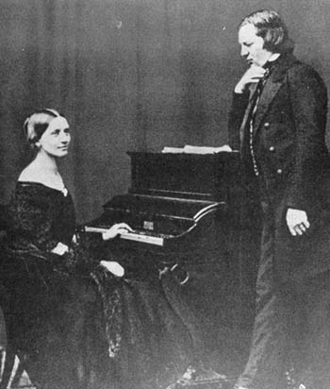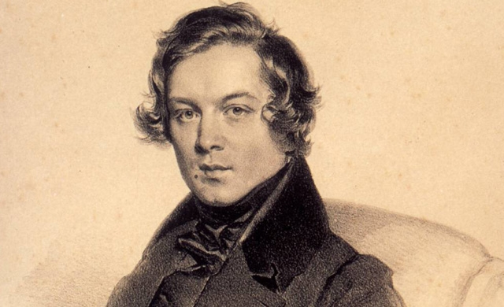
Robert and his wife Clara Robert Alexander Schumann

Works Cited
Aguirre, B. (2012, June 18). The classical piano music of Robert Schumann: The Carnaval. Retrieved from http://wayseeker.hubpages.com/hub/Classical-Piano-The-Schumann-CarnavalRecording-Program-Notes

Britannica. (N.d.). Musical Criticism. Retrieved from http://www.britannica.com/EBchecked/topic/399158/musical-criticism

Classical Archives. (2008). Robert Alexander Schumann. Retrieved from http://www.classicalarchives.com/composer/3313.html

Guitar Press. (N.d.). Schumann, his Life and Famous Works. Retrieved from http://www.guitarpress.com/Schumann.html

Libbey, T. (2010, June 07). The Life and Music of Robert Schumann. Retrieved from http://www.npr.org/2011/07/18/127038609/the-life-and-music-of-robert-schumann

8 Notes. (N.d.). Robert Schumann Biography. Retrieved from http://www.8notes.com/biographies/schumann.asp

